Kubernetes Task-04
Task 1 — Deployment with 3 Replicas and Rolling Update
Objective
Create an Nginx Deployment with:
- 3 replicas
- RollingUpdate strategy
- Update Nginx version
- Observe the rolling update

Step 1: Create YAML
Create:
vi nginx-rolling.yaml
Paste:
apiVersion: apps/v1
kind: Deployment
metadata:
name: nginx-rolling
spec:
replicas: 3

strategy:
type: RollingUpdate
rollingUpdate:
maxSurge: 1
maxUnavailable: 1

selector:
matchLabels:
app: nginx-rolling

template:
metadata:
labels:
app: nginx-rolling

spec:
containers:
- name: nginx
image: nginx:1.25
ports:
- containerPort: 80
Save:
ESC
:wq

Step 2: Create Deployment
kubectl apply -f nginx-rolling.yaml
Check:
kubectl get deployment
Expected:
NAME READY UP-TO-DATE AVAILABLE
nginx-rolling 3/3 3 3

Step 3: Check ReplicaSets
kubectl get rs
Check pods:
kubectl get pods -o wide
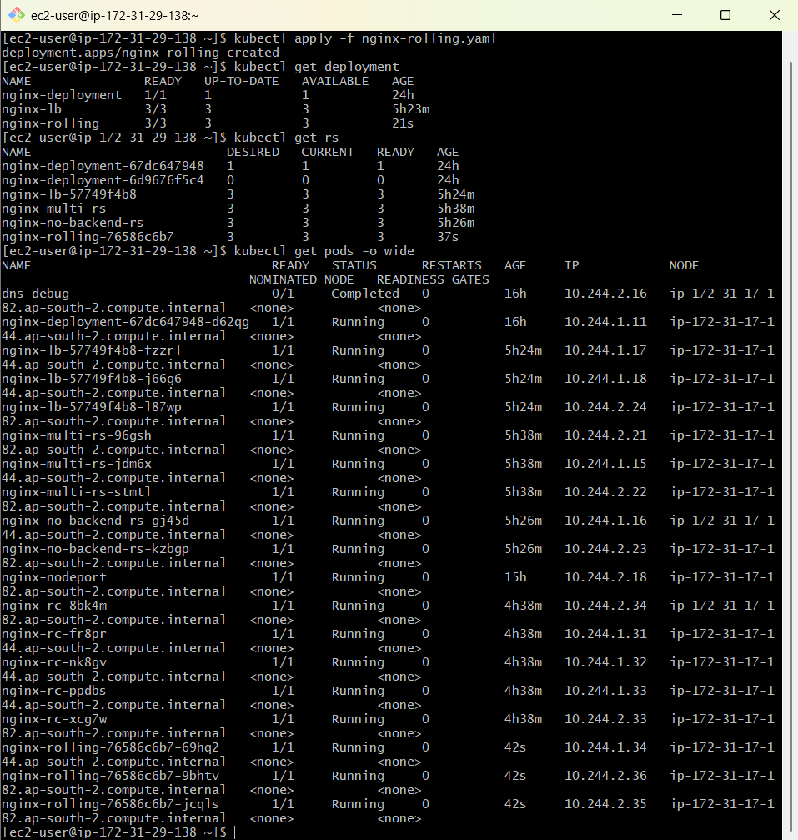

Step 4: Update Nginx Version
Change:
image: nginx:1.25
to:
image: nginx:1.27
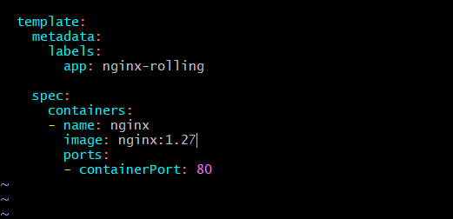
Then:
kubectl apply -f nginx-rolling.yaml
Watch the update:
kubectl rollout status deployment/nginx-rolling
Or:
kubectl get pods -w
You should see old pods being terminated and new pods being created.
Important interview point
RollingUpdate updates Pods gradually instead of stopping all Pods at once.
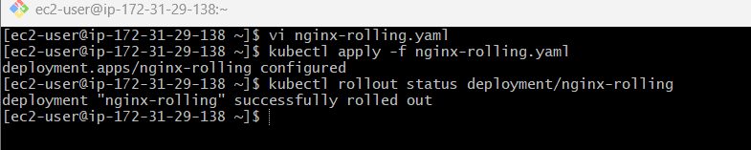

Task 2 — Recreate Strategy and Observe Downtime
Objective
Understand the difference between:
RollingUpdate
and:
Recreate

Step 1: Create YAML
vi nginx-recreate.yaml
Paste:
apiVersion: apps/v1
kind: Deployment
metadata:
name: nginx-recreate
spec:
replicas: 3

strategy:
type: Recreate

selector:
matchLabels:
app: nginx-recreate

template:
metadata:
labels:
app: nginx-recreate

spec:
containers:
- name: nginx
image: nginx:1.25
ports:
- containerPort: 80

Step 2: Create Deployment
kubectl apply -f nginx-recreate.yaml
Check:
kubectl get pods
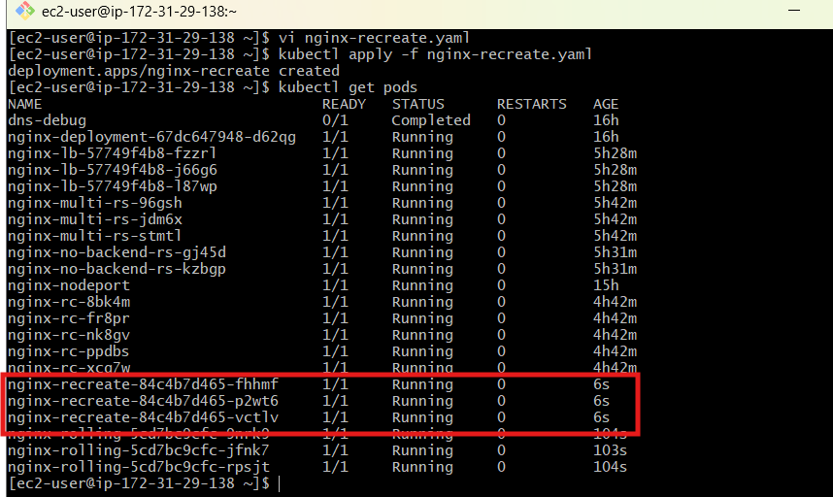

Step 3: Update Image
Change:
image: nginx:1.25
to:
image: nginx:1.27
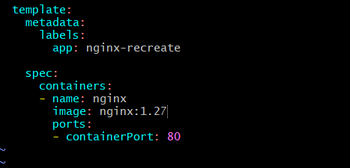
Apply:
kubectl apply -f nginx-recreate.yaml
Immediately watch:
kubectl get pods -w
With Recreate, Kubernetes terminates the existing Pods before creating the new Pods.
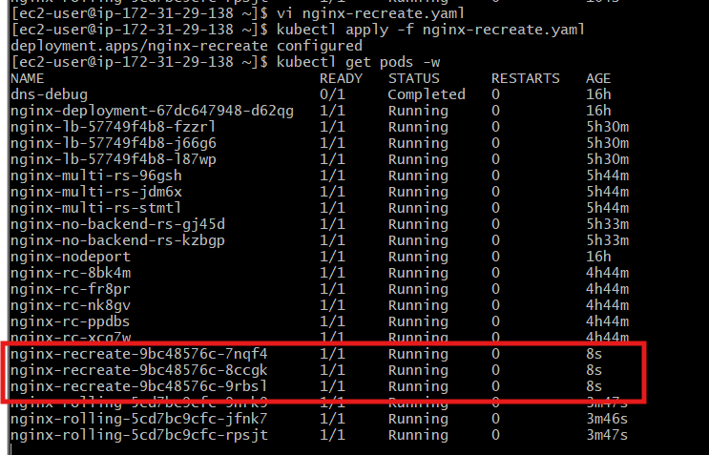
Conceptually:
Old Pods
Pod 1
Pod 2
Pod 3

↓

Terminate ALL

↓

No Pods temporarily

↓

Create new Pods

↓

Pod 1
Pod 2
Pod 3
Interview point
Recreate can cause downtime, whereas RollingUpdate is designed to maintain availability during the update.

Task 3 — Update Deployment and Rollback
Objective
Deploy version 1, update to version 2, then rollback to version 1.

Step 1: Create Deployment
vi nginx-rollback.yaml
apiVersion: apps/v1
kind: Deployment
metadata:
name: nginx-rollback
spec:
replicas: 3

selector:
matchLabels:
app: nginx-rollback

template:
metadata:
labels:
app: nginx-rollback

spec:
containers:
- name: nginx
image: nginx:1.25
ports:
- containerPort: 80
Apply:
kubectl apply -f nginx-rollback.yaml

Step 2: Check rollout history
kubectl rollout history deployment/nginx-rollback

Step 3: Update Image
kubectl set image deployment/nginx-rollback nginx=nginx:1.27
Check:
kubectl rollout status deployment/nginx-rollback
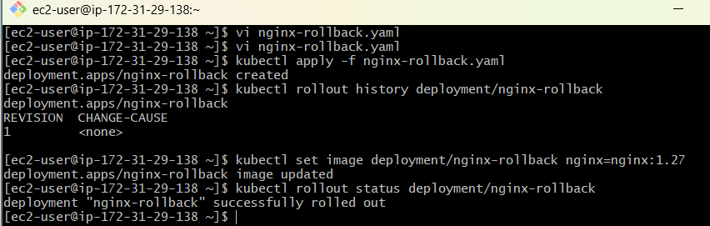

Step 4: Check History
kubectl rollout history deployment/nginx-rollback
You should see revisions such as:
REVISION
1
2

Step 5: Rollback
kubectl rollout undo deployment/nginx-rollback
Check:
kubectl rollout status deployment/nginx-rollback
Verify image:
kubectl get deployment nginx-rollback -o=jsonpath='{.spec.template.spec.containers[0].image}'
Expected:
nginx:1.25
Interview point
Rollback is used when a new application version causes problems.
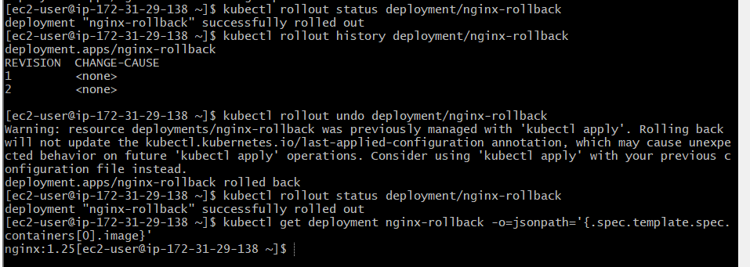

Task 4 — Add CPU and Memory Requests/Limits
Objective
Configure:
- CPU request
- CPU limit
- Memory request
- Memory limit

Step 1: Create YAML
vi nginx-resources.yaml
apiVersion: apps/v1
kind: Deployment
metadata:
name: nginx-resources
spec:
replicas: 2

selector:
matchLabels:
app: nginx-resources

template:
metadata:
labels:
app: nginx-resources

spec:
containers:
- name: nginx
image: nginx:1.27

resources:
requests:
cpu: "100m"
memory: "128Mi"

limits:
cpu: "500m"
memory: "256Mi"

ports:
- containerPort: 80
Apply:
kubectl apply -f nginx-resources.yaml

Step 2: Verify
kubectl describe pod -l app=nginx-resources
Look for:
Requests:
cpu: 100m
memory: 128Mi

Limits:
cpu: 500m
memory: 256Mi
Understand this
requests = minimum resources Kubernetes uses for scheduling

limits = maximum resources container can use
For example:
CPU request = 100m
CPU limit = 500m

Memory request = 128Mi
Memory limit = 256Mi
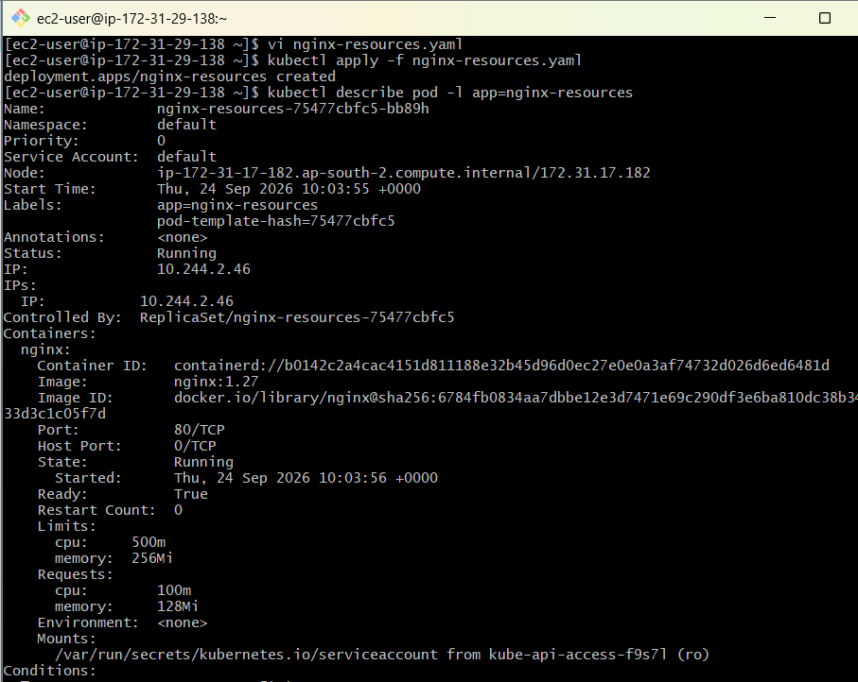

Task 5 — MaxSurge and MaxUnavailable
This is an important interview topic.
Objective
Configure:
maxSurge
maxUnavailable

Step 1: Create Deployment
vi nginx-surge.yaml
apiVersion: apps/v1
kind: Deployment
metadata:
name: nginx-surge
spec:
replicas: 4

strategy:
type: RollingUpdate

rollingUpdate:
maxSurge: 2
maxUnavailable: 1

selector:
matchLabels:
app: nginx-surge

template:
metadata:
labels:
app: nginx-surge

spec:
containers:
- name: nginx
image: nginx:1.25
Apply:
kubectl apply -f nginx-surge.yaml

Step 2: Check
kubectl get deployment nginx-surge
Then:
kubectl get pods
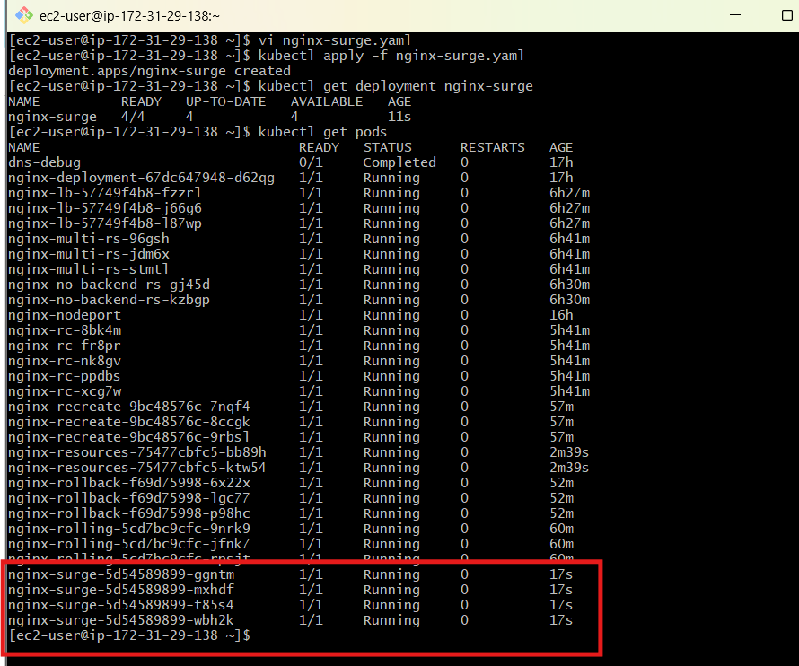

Step 3: Update Image
kubectl set image deployment/nginx-surge nginx=nginx:1.27
Watch:
kubectl get pods -w
Meaning
We have:
replicas = 4
maxSurge = 2
maxUnavailable = 1
During update Kubernetes can temporarily create up to 2 additional Pods above the desired replica count, while allowing up to 1 Pod to be unavailable.
So the rollout can temporarily have:
Desired = 4

Maximum = 6
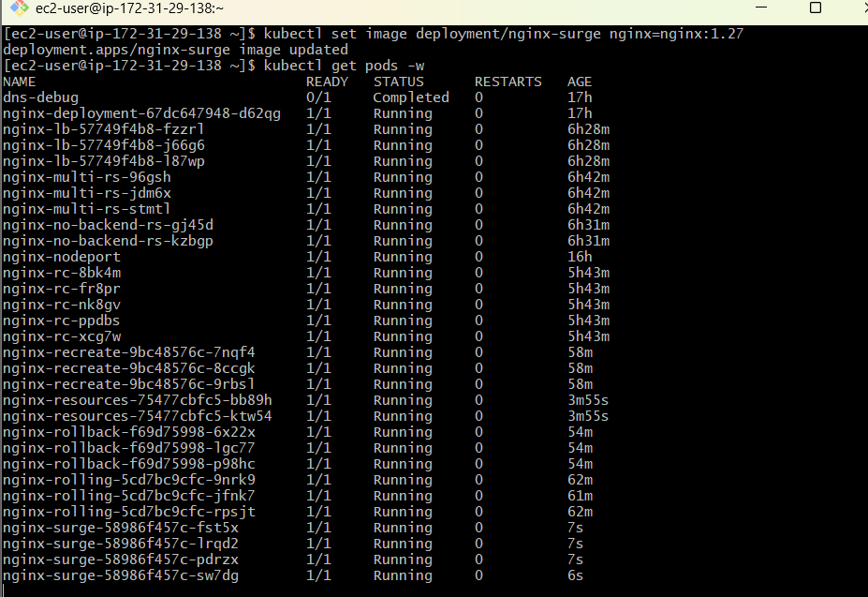

Task 6 — Custom Revision History Limit
Objective
Control how many old ReplicaSets Kubernetes retains.

Step 1: Create YAML
vi nginx-history.yaml
apiVersion: apps/v1
kind: Deployment
metadata:
name: nginx-history

spec:
replicas: 3

revisionHistoryLimit: 3

selector:
matchLabels:
app: nginx-history

template:
metadata:
labels:
app: nginx-history

spec:
containers:
- name: nginx
image: nginx:1.25
Apply:
kubectl apply -f nginx-history.yaml

Step 2: Perform Updates
Run:
kubectl set image deployment/nginx-history nginx=nginx:1.26
Then:
kubectl set image deployment/nginx-history nginx=nginx:1.27
Then another version if available in your lab.
Check:
kubectl rollout history deployment/nginx-history
Check ReplicaSets:
kubectl get rs
Important
revisionHistoryLimit: 3
means Kubernetes retains up to 3 old revisions for rollback/history purposes.
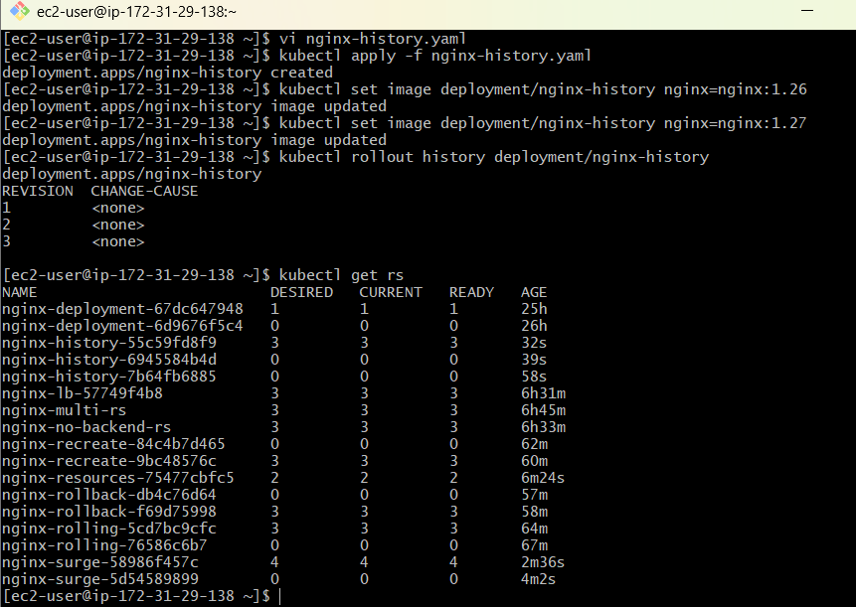

Task 7 — Pause Deployment During Update
Objective
Pause a Deployment rollout, make changes, then resume it.

Step 1: Create Deployment
You can use the previous Deployment or create:
kubectl create deployment nginx-pause --image=nginx:1.25 --replicas=3
Check:
kubectl get deployment nginx-pause

Step 2: Pause Deployment
kubectl rollout pause deployment/nginx-pause
Verify:
kubectl rollout status deployment/nginx-pause
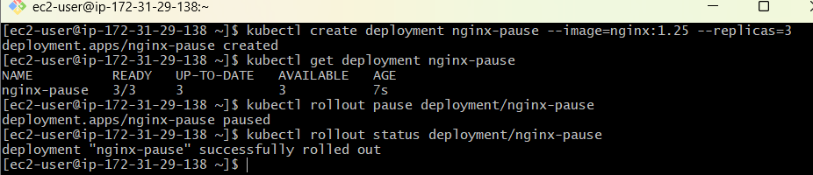

Step 3: Make Changes
Change image:
kubectl set image deployment/nginx-pause nginx=nginx:1.26
Now change it again:
kubectl set image deployment/nginx-pause nginx=nginx:1.27
Because the Deployment is paused, Kubernetes does not immediately perform the rollout.
Check:
kubectl get pods
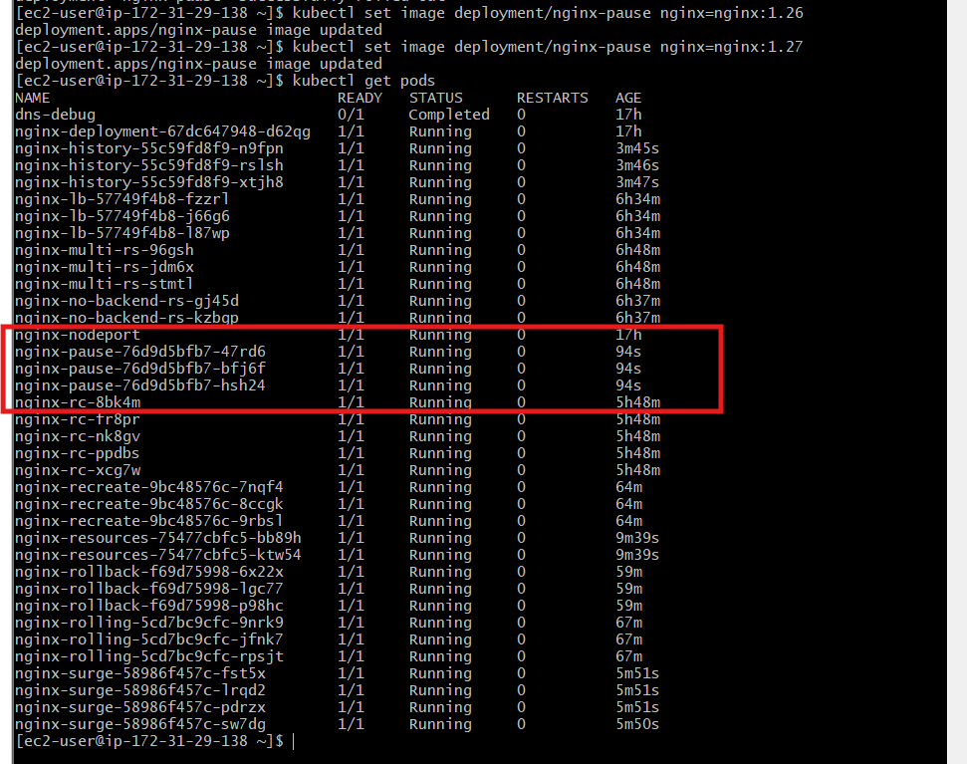

Step 4: Resume
kubectl rollout resume deployment/nginx-pause
Check:
kubectl rollout status deployment/nginx-pause
Verify:
kubectl get pods
Interview point
Pause is useful when you want to make multiple changes together and then trigger the rollout after all changes are ready.
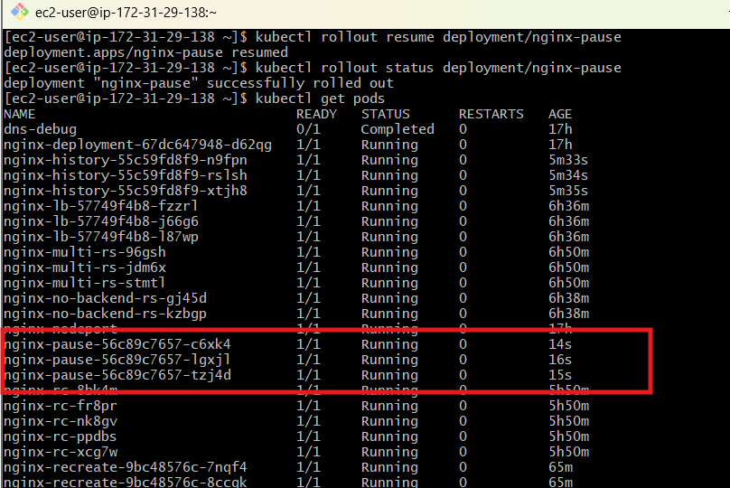

Task 8 — Pod with CPU/Memory Requests and Scheduler
This task is very important for understanding Kubernetes scheduling.
Objective
Create a Pod with resource requests and observe which node Kubernetes selects.

Step 1: Check Nodes
kubectl get nodes -o wide
Example:
NAME STATUS ROLES
master Ready control-plane
worker1 Ready <none>
worker2 Ready <none>
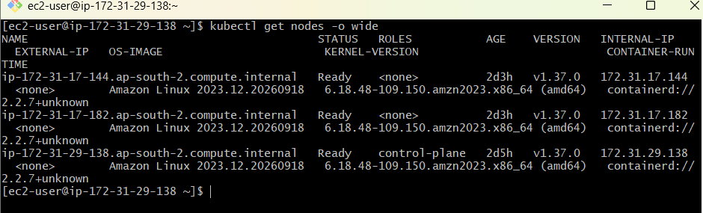

Step 2: Create Pod YAML
vi resource-pod.yaml
Paste:
apiVersion: v1
kind: Pod

metadata:
name: resource-pod

spec:
containers:
- name: nginx
image: nginx:1.27

resources:
requests:
cpu: "500m"
memory: "256Mi"

limits:
cpu: "1"
memory: "512Mi"
Apply:
kubectl apply -f resource-pod.yaml

Step 3: Check Pod
kubectl get pod resource-pod -o wide
You should see:
NAME READY STATUS IP NODE
resource-pod 1/1 Running 10.x.x.x worker1
The important column is:
NODE
That tells you where the Kubernetes scheduler placed the Pod.
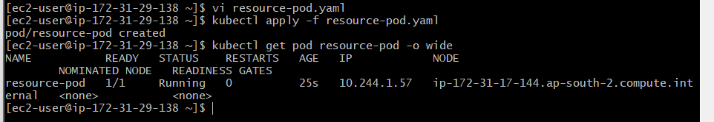

Step 4: Describe Pod
kubectl describe pod resource-pod
Look at:
Node:
and:
Requests:
cpu: 500m
memory: 256Mi

Limits:
cpu: 1
memory: 512Mi
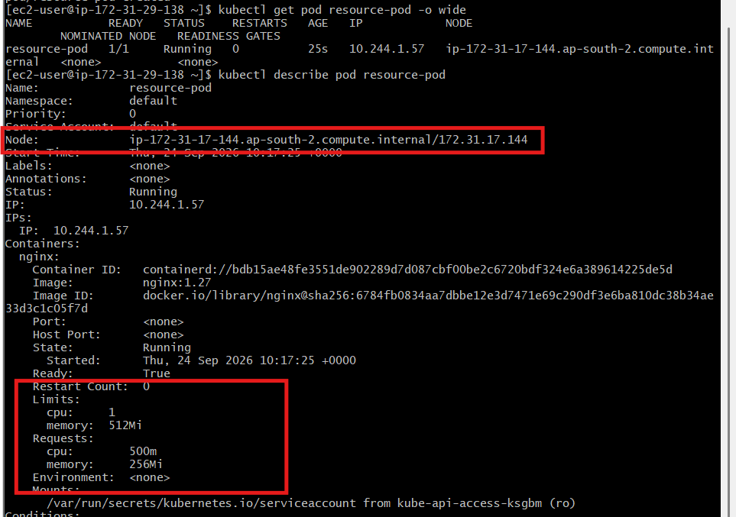

Understand How Scheduler Works
The basic flow is:
Pod YAML
|
↓
Resource Requests
|
↓
Kubernetes Scheduler
|
┌────────┴────────┐
↓ ↓
Worker 1 Worker 2
| |
↓ ↓
Available Available
Resources Resources
|
↓
Suitable Node
|
↓
Pod
The scheduler primarily considers the resource requests when determining whether a node has enough allocatable resources for the Pod.
For example:
Pod requires:

CPU = 500m
Memory = 256Mi
If Worker 1 has insufficient available allocatable resources, the scheduler can consider another suitable node.

